CREATE JAVA APPLICATION

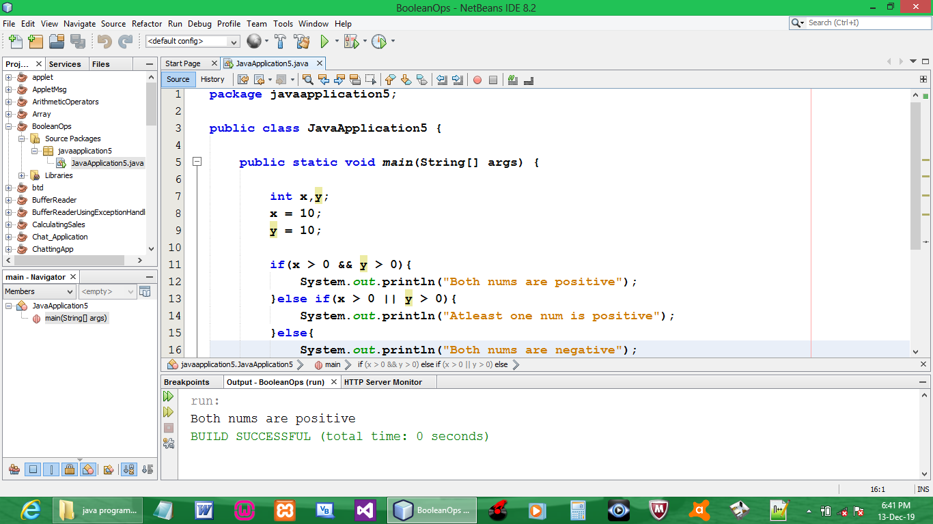

CODE:

package javaapplication5;

public class JavaApplication5 {

public static void main(String[] args) {

int x,y;
x = 10;
y = 10;

if(x > 0 && y > 0){
System.out.println("Both nums are positive");
}else if(x > 0 || y > 0){
System.out.println("Atleast one num is positive");
}else{
System.out.println("Both nums are negative");
}
}
}

OUTPUT:

